
The University of Azad Jammu and Kashmir, Muzaffarabad.

Software Engineering Fundamentals

Prepared By: | Raja Afzal Ajmal
Roll No: | 2024-SE-25
Lab | 01
Instructor: | Engr. Dr. Asma Javaid
Session | 2024-2028
Course Name | Software Construction & Development
Submission Date: | 25-October-2026

Department of Software Engineering
Lab 01: User Case Diagrams
Question 1: Online Ticket Reservation System
Task Requirement: Using your knowledge of how a ticket is reserved online, develop a use case diagram that could serve as a basis for understanding the requirements for an online ticket reservation system.
1. System Identification & Actors
The Online Ticket Reservation System facilitates automated browsing, seat selection, booking, and payment processing for customers while giving system administrators management capabilities.
- Customer (Primary Actor): Interacts with the system to search for available tickets/events, select seat preferences/classes, place bookings, execute secure payments, view or download e-tickets, and manage/cancel reservations.
- Payment Gateway (Secondary External Actor): External payment infrastructure (e.g., credit card processor/bank API) responsible for verifying card details and completing monetary transactions securely.
- System Administrator (Primary Internal Actor): Maintains event/travel schedules, updates pricing configurations, manages available ticket inventories, and monitors system logs.

2. Identified Use Cases & Relationships
Use Case Name | Participating Actor(s) | Relationship / Description
Search Tickets / Events | Customer | Primary association; allows searching by date, location, or event type.
Select Seats / Class | Customer | <<include>> relationship with 'Book Ticket'; mandatory step before booking.
Book Ticket | Customer | Core reservation process; triggers seat selection and payment execution.
Make Payment | Customer, Payment Gateway | <<include>> relationship with 'Book Ticket'; requires external payment gateway processing.
View / Download E-Ticket | Customer | Primary association; retrieves electronic confirmation/PDF ticket after booking.
Cancel Reservation | Customer | Primary association; enables cancellation of existing reservations subject to policy.
Manage Schedules & Prices | System Administrator | Primary administrative use case for updating inventory, routes, and fare structures.

3. Use Case Diagram (Question 1)

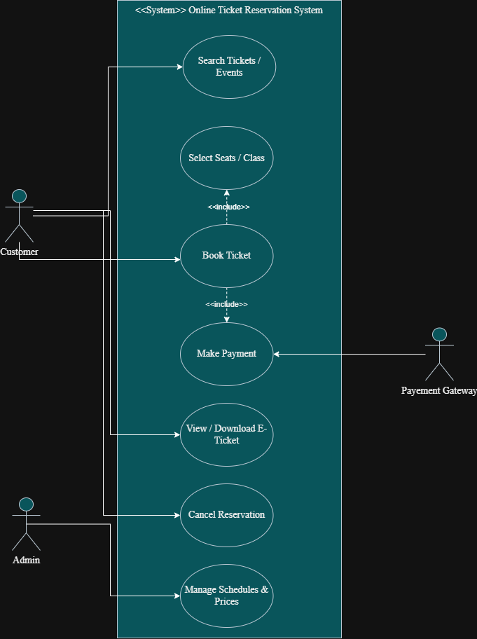
Question 2: Credit Card Processing System
Case Study Summary: The Credit Card Processing System is used to purchase items at a shop/mall, maintain credit card balance limits, and update transaction processes via a credit card machine. The customer selects items, the vendor creates the bill, the customer hands over the card to swap, the card reader executes the required transaction, the vendor issues the printed statement/receipt, and the customer signs the receipt and returns it to the vendor.
Part (a): Identification of Actors and Use Cases
1. Identified Actors
- Customer: Initiates the purchase by selecting items from the store, hands over the credit card for payment processing, signs the printed receipt, and returns the signed copy to the vendor.
- Vendor: Calculates item totals, generates the bill, receives and swipes the customer's credit card through the card reader, and hands the printed balance statement/receipt to the customer.
- Credit Card Machine (Card Reader / Payment Hardware): Automated hardware actor that reads credit card data, verifies balance limits, executes the transaction, and prints the balance receipt.
2. Identified Use Cases & Detailed Workflow Mapping
Use Case Name | Participating Actor(s) | Relationship / Description
Select Item | Customer | Customer selects product(s) to purchase within the shop.
Generate Bill | Vendor | Vendor calculates total costs and itemizes the bill.
Swipe Card | Vendor | Vendor passes credit card through the card reader machine.
Process Transaction | Credit Card Machine | Machine checks credit limit, validates card, and executes amount transaction (included by 'Swipe Card').
Issue Receipt | Vendor | Vendor hands printed balance receipt to customer after transaction completion (included by 'Process Transaction').
Sign Receipt | Customer | Customer signs receipt and returns it to vendor to complete transaction (included by 'Issue Receipt').
Part (b): Use Case Diagram (Question 2)
Relationship Logic: In this diagram, the core operational sequence flows vertically through included use cases: Swipe Card --<<include>>--> Process Transaction --<<include>>--> Issue Receipt --<<include>>--> Sign Receipt. Actors connect directly to the primary use cases they interact with.
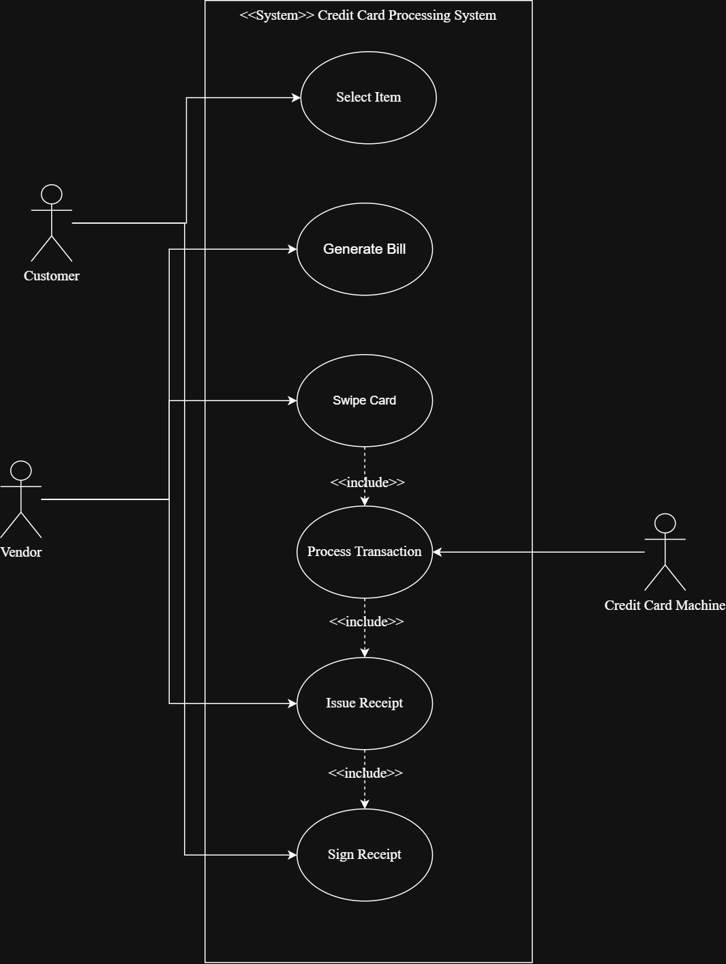

Lab Submission Summary & Quality Verification
- QOBE Submission Compliance: This lab document is structured strictly for upload to the QOBE portal within the designated submission window.
- UML 2.5 Standard Adherence: All diagrams strictly distinguish primary actors, secondary automation actors, system boundary boxes, and <<include>> dependencies.
- Visual Verification: Screenshots should be inserted directly into the highlighted callout boxes above before exporting/saving the final document for grading.

